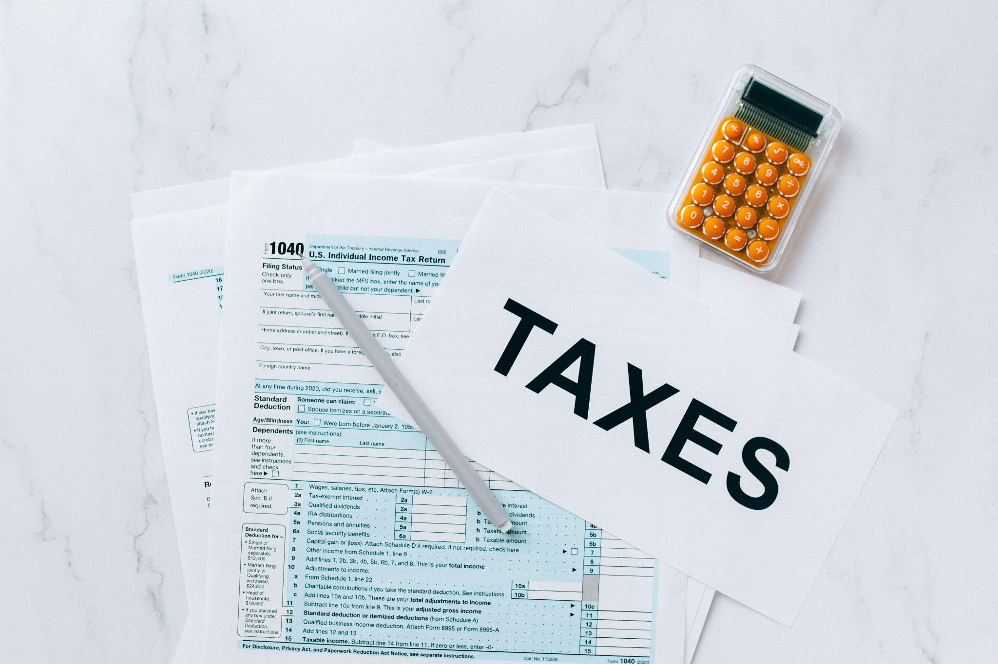
Image Credit

The Tax Implications of Owning A Rental Property in Canada

Securing a rental property in Canada is a great way to build your wealth and retire early, but you need to understand the nitty-gritty of the investment so that you generate the wealth you expect without any surprises. Read on to understand more about real estate tax in Canadian provinces.

Canadian Real Estate Tax
When it comes to investing in a Canadian property, there is good news and bad news, the good news is that Canadian property - particularly Canadian rental property - is a lucrative and enjoyable way to make wealth work for you and retire early, but there are tax considerations.

When you invest in a Canadian property, you will be subject to a provincial tax called a transfer tax - the type of tax differs depending on the province in which you own property. In general, the tax is 1% on the first $200,000 and 2% on the balance, but you will have to carry out research.

Another Canadian real estate tax levy to look out for is the annual property taxes that is based on the property type and the market value. Canadian real estate comes with taxes, but don’t let that put you off; a Canadian property is a lucrative long-term investment for your retirement.

Rental Property Tax
If you own a rental property in Canada, you need to pay 25% of the gross property rental income for the year; this is set out in The Canadian Income Tax Act. Hopefully, your rental property is generating enough income for you to manage your rental tax responsibilities.

If 25% sounds substantial, there is a simple way to reduce the amount you pay annually. Non-residents can select to pay 25% of the net rental income after expenses instead of the gross rental income, which reduces your tax fees; all you have to do is fill out an NR6 form.

In the event that your rental property incurs a loss at the end of the year, you can reclaim any previously paid taxes. The tax you pay on the rental property depends on whether you are a co-owner or partner and whether the rental income is considered to be a business income.

Tax rates and Deductions
Owning a rental property in Canada is considered to be a small business, and any income you receive is revenue that you must pay tax on. Whether you are the sole owner of the property or the co-owner, you must disclose any income you receive on your annual tax return submission.

It is worth noting that co-owners are only required to submit their portion of the income and not the total income for the property. Tax rates depend on the province and property type. The basic tax rate is 25%, but it can rise to as much as 48% in some provinces, such as Alberta province.

Only the net income is taxable, and this can be reduced with various deductions. Deductible expenses can include property taxes, insurance premiums, condo fees, utilities, and advertising. Mortgage interest can also be deducted, but the principal mortgage sum is non-deductible.

Maintenance and Improvements
There is a difference between the tax paid on maintenance and improvement costs. In simple terms, a maintenance cost is a deductible expense, and an improved cost is a non-deductible expense. For instance, a new roof is non-deductible, but plumping is a deductible expense.

If you are making an improvement to the rental property that adds value to it over time, such as installing a new roof or a new heating system, you cannot deduct this from the end-of-year taxes; but if the upgrade serves to return the property to a natural condition, it is deductible.

Other Taxes and Fees
The taxes and deductions outlined above are standard for rental properties in Canada, although there are some variations depending on the province. However, there are some additional taxes and fees to be aware of when investing in property, including land transfer and estate probate.

If you have some property in multiple provinces, such as a residency and additional rental property, the fees and taxes can become quite significant. These fees and taxes are unavoidable, so it is best to contact a tax advisor before securing a property in other areas.

Some Final Thoughts
Canadian rental property is a sound investment strategy - it is both lucrative and enjoyable - however, owning Canadian property doesn’t come without taxes and fees. While these are mostly unavoidable, there are deductions to make; contact RPI Education to find out more. Why not browse through the courses we offer or join out of our monthly free events.

